**ICE-Dashboard-2022-2023**

The aim of this project was to develop a dynamic dashboard that represents the Social Corporate Responsibility (CSR) project of ICE Data Services, which is carried out in collaboration with the AIF (American Indian Foundation). The CSR project focuses on teaching fintech to students across 30 different schools located in five different cities across two states. A total of 29 fintech sessions were planned to be completed in these schools.

The project cities include Hyderabad, Rangareddy, Guntur, Bapatla, and Palnadu in the states of Telangana and Andhra Pradesh. The dashboard provides various permutations and combinations of data to effectively analyze the project's progress. It consists of two pages, where the first page offers a district-wise comparison, while the second page provides a school-wise comparison.

The primary data for the project was initially provided in Excel sheets, which were then loaded, transformed, and modeled using power query in Google Sheets. The stakeholders and the team lead were highly satisfied with the work. The dashboard provided valuable insights into the current stage of the project, identified drawbacks, and assisted in future planning for the project's success.

The dashboard :

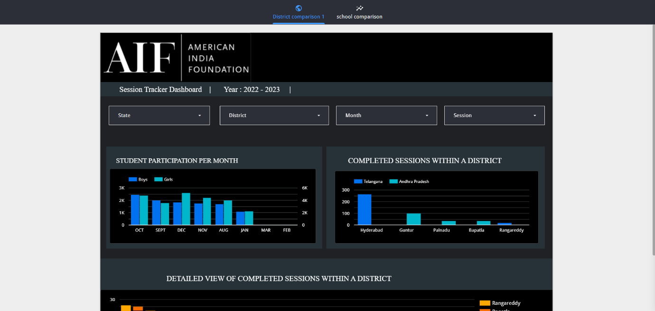

The first page of the dashboard provides a comprehensive district-wise comparison of the data. It includes two key graphs that offer valuable insights into the project.

The first graph focuses on overall student participation, depicting the number of boys and girls who actively participated in sessions across different months. This visualization helps track the gender distribution and engagement trends over time, allowing for a better understanding of the program's reach and impact.

Moving on to the second graph, it highlights the total number of completed sessions across the five cities involved in the project. This visualization presents a clear overview of the progress made in each city, facilitating a comparative analysis of session completion rates and helping identify any variations or patterns that may exist.

By presenting these district-wise comparisons, the dashboard provides stakeholders and team leads with a comprehensive snapshot of the project's performance. It enables them to assess student participation, monitor progress across different months and cities, and make informed decisions regarding future planning and resource allocation.

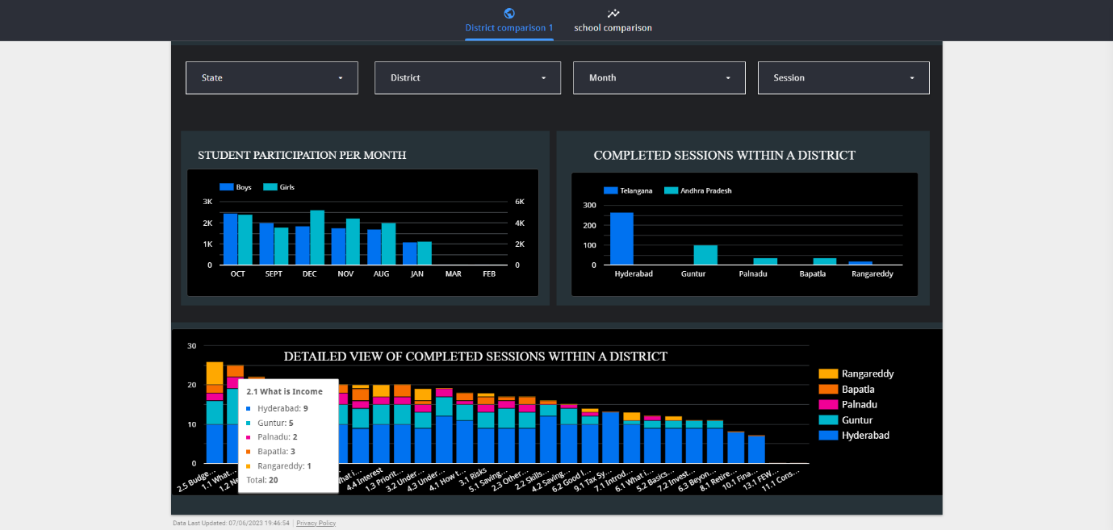

On the first page of the dashboard, there is a graph that provides a session-wise comparison across districts, highlighting the number of completed sessions in each district. This graph effectively visualizes the distribution of sessions and their progress within different districts.

The x-axis represents the session names, while each bar on the graph is color-coded to represent a specific district. This visual representation offers a quick and intuitive understanding of the session counts for each district.

Specifically, one of the bars on the graph provides a detailed description of a district's session count. It shows the district name and the corresponding number of sessions conducted in that district. This information allows stakeholders and team leads to analyze and compare the session completion rates across districts, gaining insights into the level of engagement and progress in different areas.

By leveraging this session-wise comparison graph, project coordinators can assess the effectiveness and distribution of sessions, identify any discrepancies or patterns, and make data-driven decisions to optimize resource allocation and ensure equitable access to learning opportunities throughout the districts.

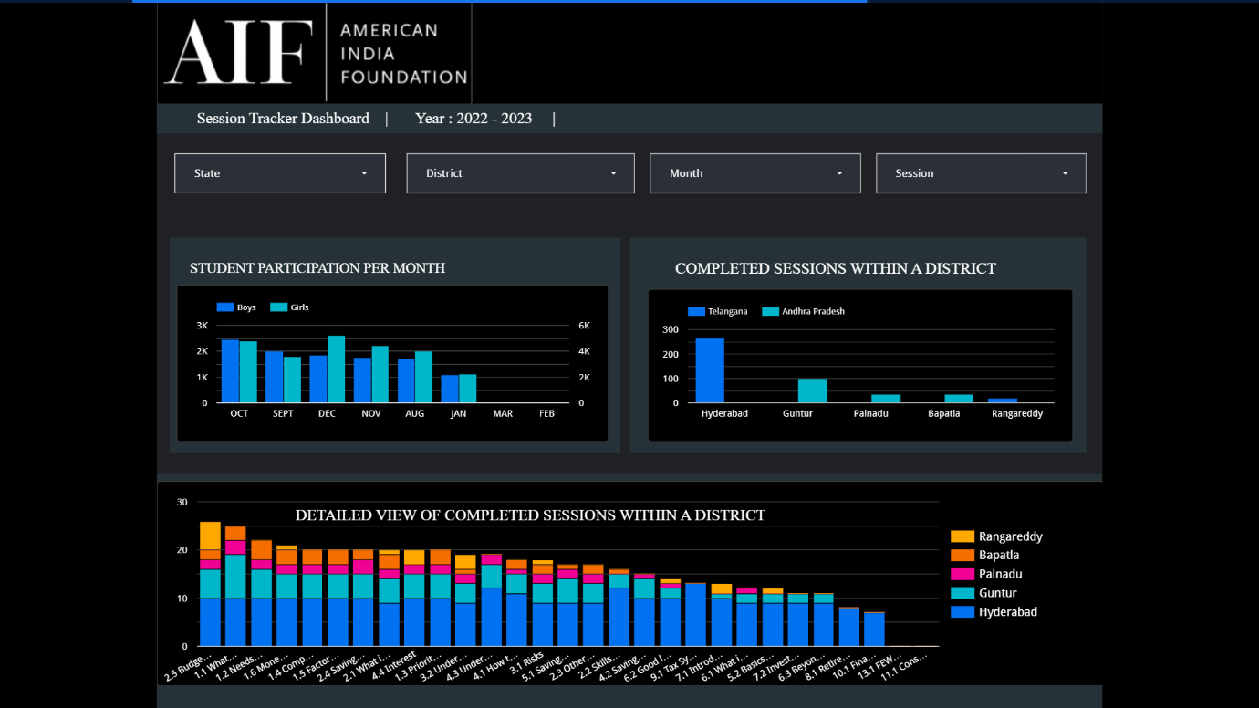

*Full view of first page*

Page two :

*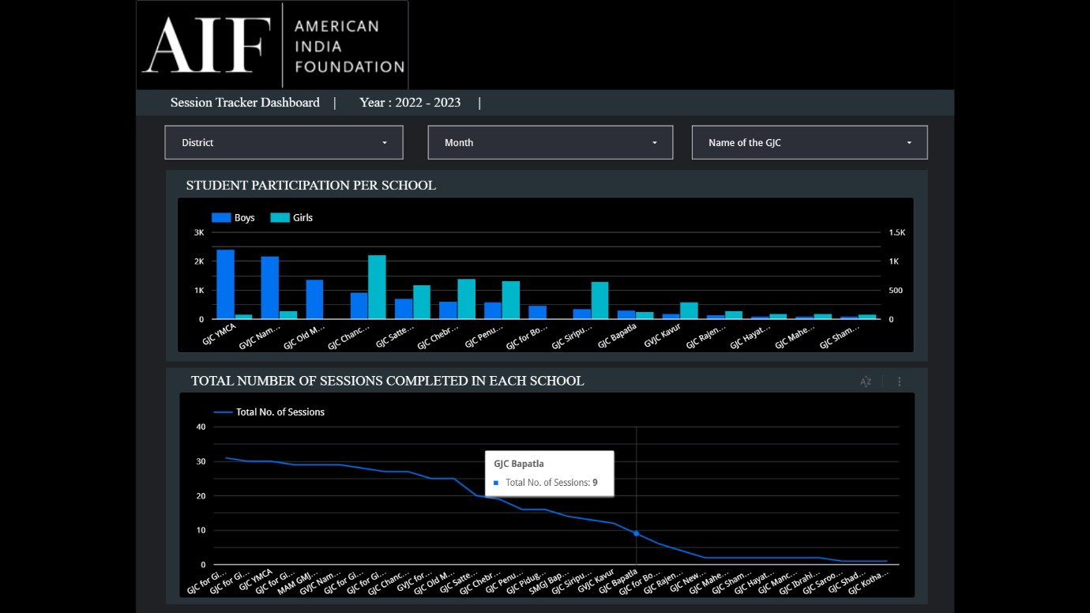Here the name of GJC is the name of schools*

The second page of the dashboard focuses on school-wise comparison, providing valuable insights into session tracking. The first graph on this page displays the number of students who participated in each session, along with a breakdown of boys and girls participation. Boys are represented by the color blue, while girls are represented by the color cyan.

This graph allows for a detailed analysis of student participation in each session, offering a visual representation of the gender distribution within the sessions. By observing the graph, stakeholders can quickly identify the number of boys and girls present in each session, enabling them to monitor and assess gender balance and engagement levels.

The school-wise comparison graph on the second page of the dashboard enhances the understanding of student participation trends and enables stakeholders to make informed decisions. By recognizing variations in boys and girls' attendance across sessions, it aids in identifying any potential discrepancies and developing strategies to promote equal participation and inclusive learning environments.

The second graph on the second page of the dashboard presents a line graph depicting the total number of sessions completed in each school. This visual representation offers a convenient and quick comparison of session completion across different schools.

The line graph provides a clear overview of the progress made in each school, allowing stakeholders to assess and analyze the number of sessions completed. By hovering the mouse over the graph, users can access a brief description of the data, providing additional details for each point on the graph.

Furthermore, the dashboard incorporates dropdown menus that enable users to customize the data view and explore various combinations as needed. This flexibility allows stakeholders to easily manipulate and interact with the data, generating valuable insights and facilitating in-depth analysis based on specific criteria or combinations of interest.